Heatmap

>mtcars

mpg cyl disp hp drat wt qsec vs am gear carb

Mazda RX4 21.0 6 160.0 110 3.90 2.620 16.46 0 1 4 4

Mazda RX4 Wag 21.0 6 160.0 110 3.90 2.875 17.02 0 1 4 4

Datsun 710 22.8 4 108.0 93 3.85 2.320 18.61 1 1 4 1

Hornet 4 Drive 21.4 6 258.0 110 3.08 3.215 19.44 1 0 3 1

Hornet Sportabout 18.7 8 360.0 175 3.15 3.440 17.02 0 0 3 2

Valiant 18.1 6 225.0 105 2.76 3.460 20.22 1 0 3 1

Duster 360 14.3 8 360.0 245 3.21 3.570 15.84 0 0 3 4

Merc 240D 24.4 4 146.7 62 3.69 3.190 20.00 1 0 4 2

Merc 230 22.8 4 140.8 95 3.92 3.150 22.90 1 0 4 2

Merc 280 19.2 6 167.6 123 3.92 3.440 18.30 1 0 4 4

Merc 280C 17.8 6 167.6 123 3.92 3.440 18.90 1 0 4 4

Merc 450SE 16.4 8 275.8 180 3.07 4.070 17.40 0 0 3 3

Merc 450SL 17.3 8 275.8 180 3.07 3.730 17.60 0 0 3 3

Merc 450SLC 15.2 8 275.8 180 3.07 3.780 18.00 0 0 3 3

Cadillac Fleetwood 10.4 8 472.0 205 2.93 5.250 17.98 0 0 3 4

Lincoln Continental 10.4 8 460.0 215 3.00 5.424 17.82 0 0 3 4

Chrysler Imperial 14.7 8 440.0 230 3.23 5.345 17.42 0 0 3 4

Fiat 128 32.4 4 78.7 66 4.08 2.200 19.47 1 1 4 1

Honda Civic 30.4 4 75.7 52 4.93 1.615 18.52 1 1 4 2

Toyota Corolla 33.9 4 71.1 65 4.22 1.835 19.90 1 1 4 1

Toyota Corona 21.5 4 120.1 97 3.70 2.465 20.01 1 0 3 1

Dodge Challenger 15.5 8 318.0 150 2.76 3.520 16.87 0 0 3 2

AMC Javelin 15.2 8 304.0 150 3.15 3.435 17.30 0 0 3 2

Camaro Z28 13.3 8 350.0 245 3.73 3.840 15.41 0 0 3 4

Pontiac Firebird 19.2 8 400.0 175 3.08 3.845 17.05 0 0 3 2

Fiat X1-9 27.3 4 79.0 66 4.08 1.935 18.90 1 1 4 1

Porsche 914-2 26.0 4 120.3 91 4.43 2.140 16.70 0 1 5 2

Lotus Europa 30.4 4 95.1 113 3.77 1.513 16.90 1 1 5 2

Ford Pantera L 15.8 8 351.0 264 4.22 3.170 14.50 0 1 5 4

Ferrari Dino 19.7 6 145.0 175 3.62 2.770 15.50 0 1 5 6

Maserati Bora 15.0 8 301.0 335 3.54 3.570 14.60 0 1 5 8

Volvo 142E 21.4 4 121.0 109 4.11 2.780 18.60 1 1 4 2

> data <- as.matrix(mtcars)

> heatmap(data)

> heatmap(data, scale="column")

> heatmap(data, Colv = NA, Rowv = NA, scale="column")

> heatmap(data, scale="column", col = cm.colors(256)

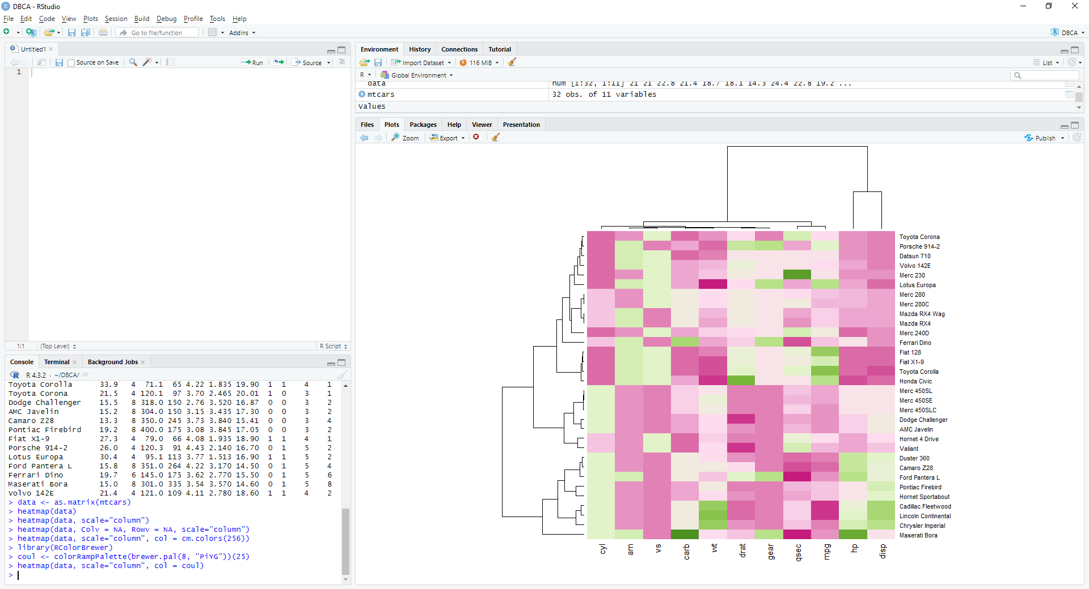

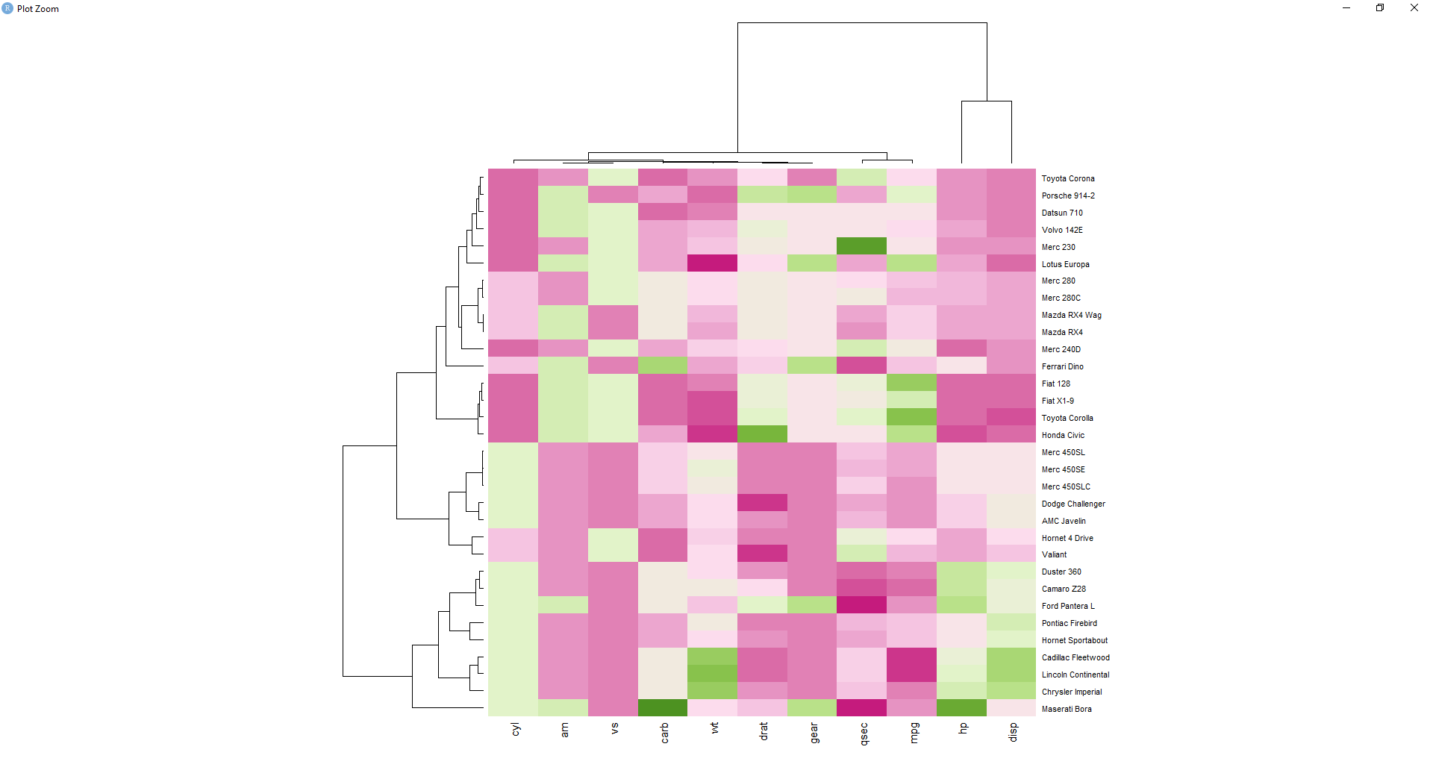

Correlación

> install.packages('corrplot')

> library(corrplot)

>c<-cor(mtcars)

>corrplot(c,method= "number")

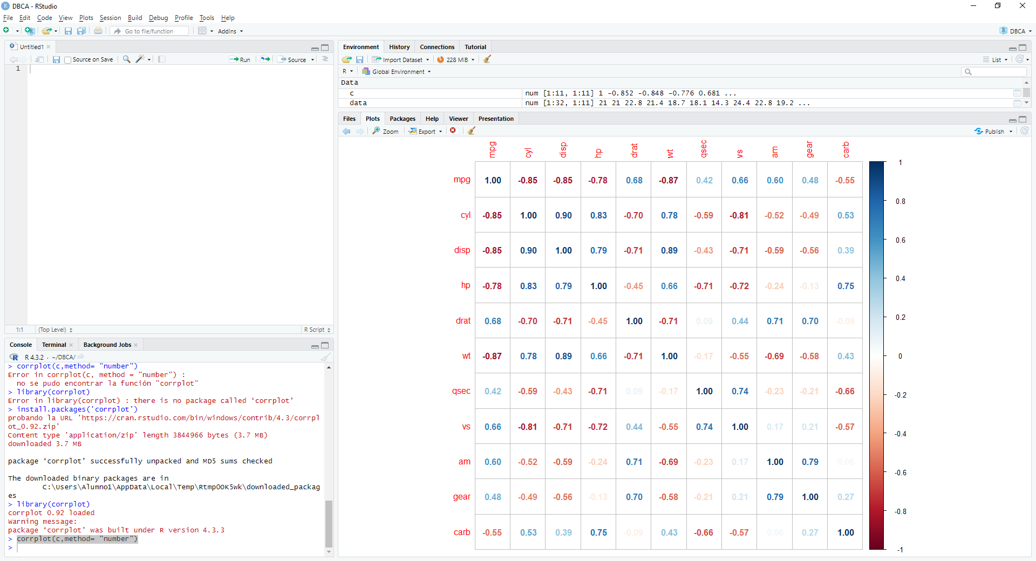

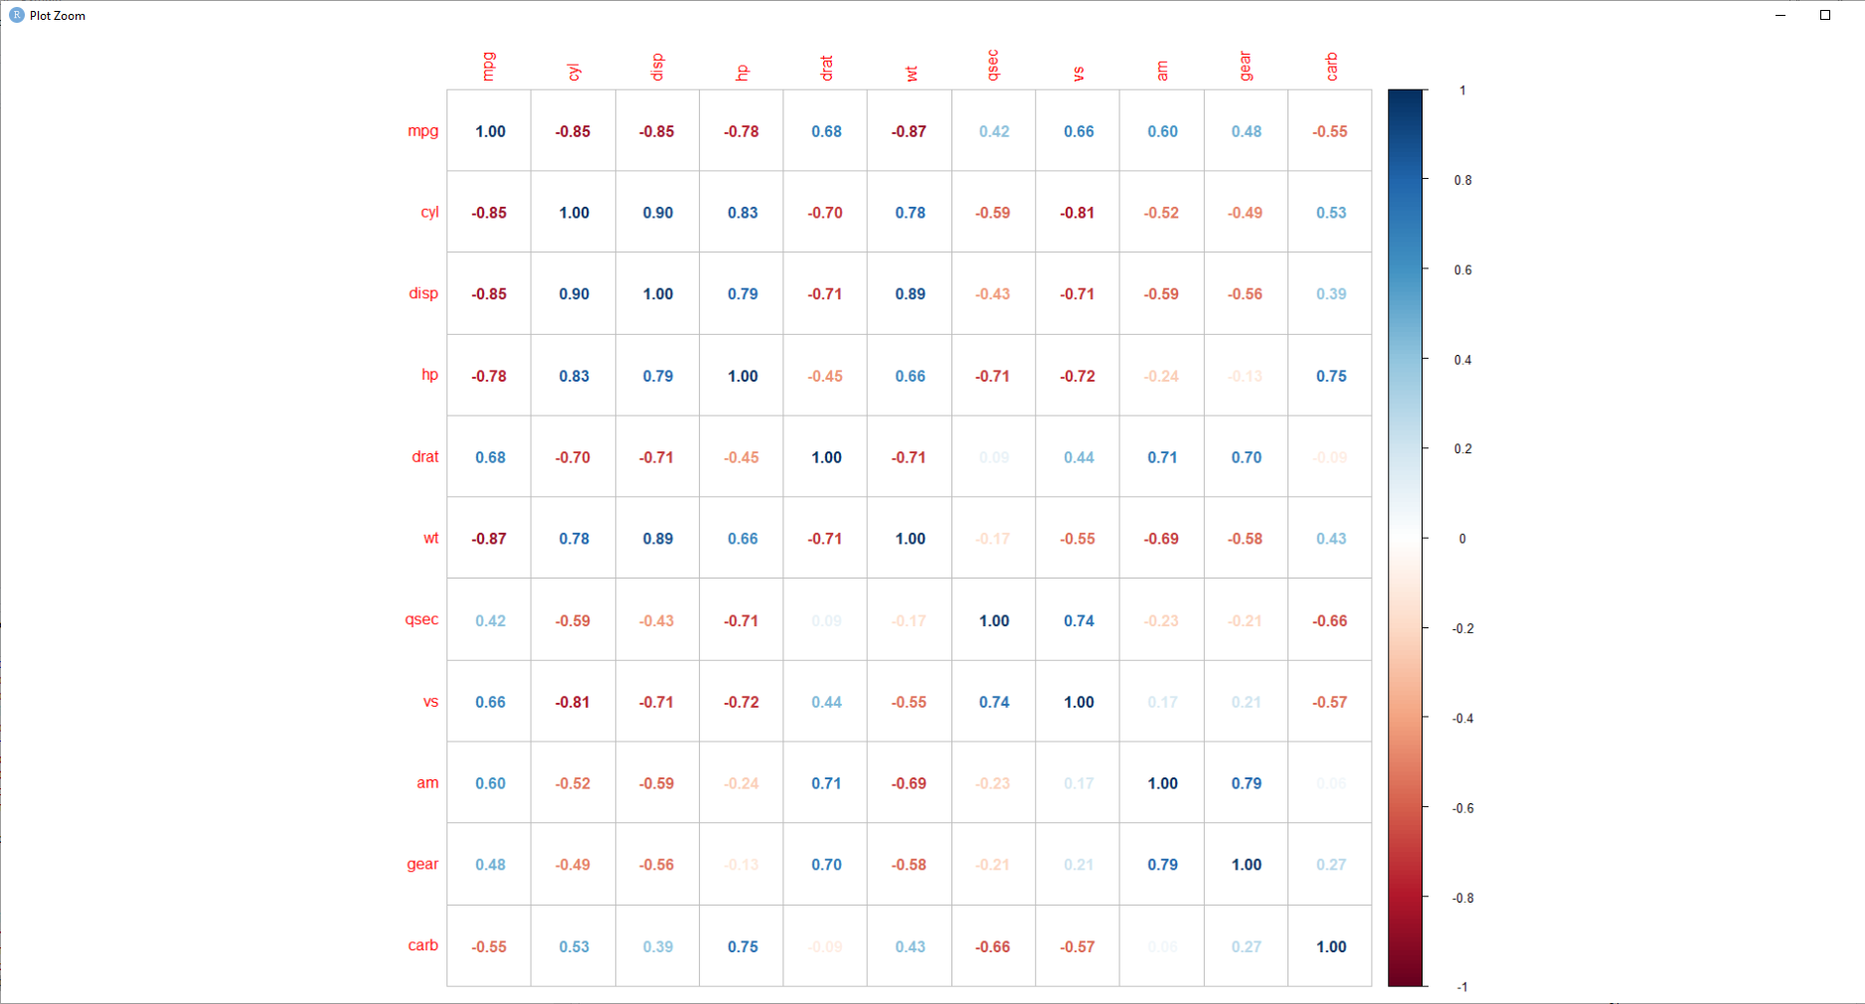

ANOVA

> anova_model<-aov(mpg~cyl,data=mtcars)

> summary(anova_model)

Df Sum Sq Mean Sq F value Pr(>F)

cyl 1 817.7 817.7 79.56 6.11e-10 ***

Residuals 30 308.3 10.3

---

Signif. codes: 0 ‘***’ 0.001 ‘**’ 0.01 ‘*’ 0.05 ‘.’ 0.1 ‘ ’ 1

|  |
| --- |
| boxplot(mpg~cyl, data=mtcars, col=c("lightpink", "lightyellow", "lightblue"), main="ANOVA Bloxplot") |
|  |
|  |

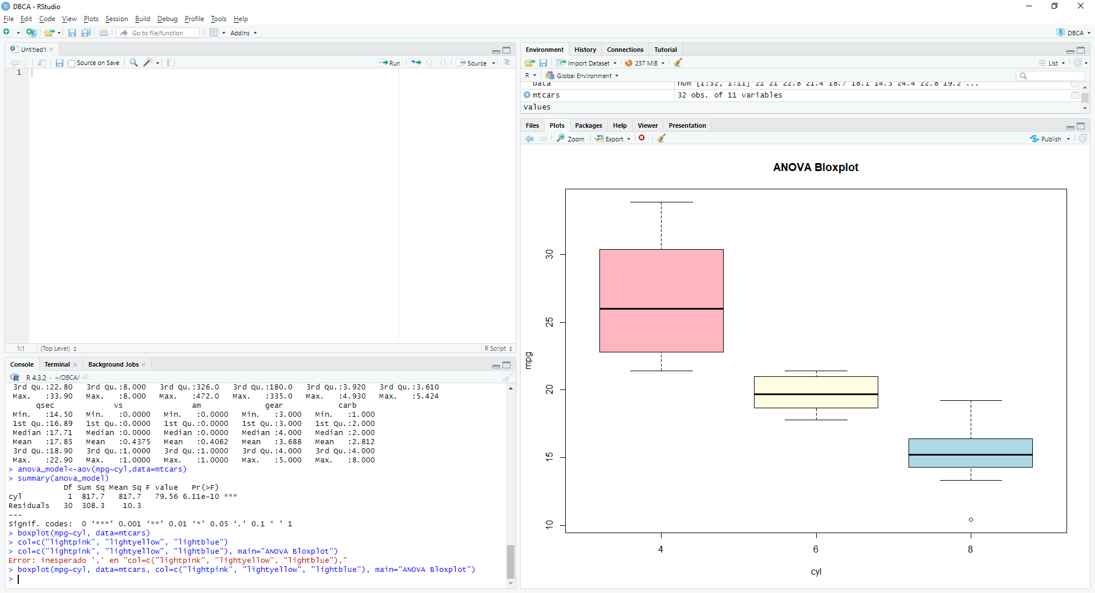

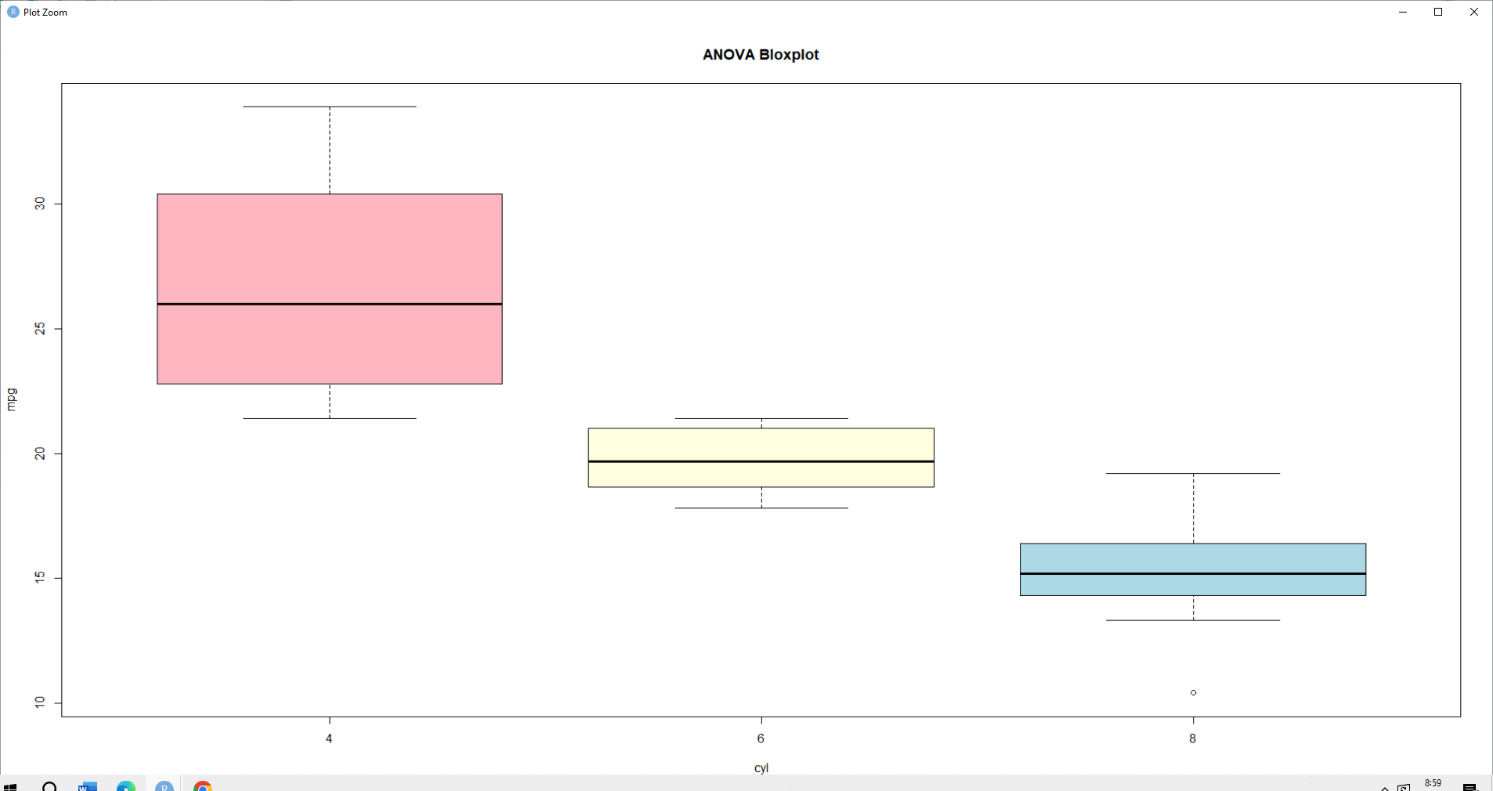

Loop Mean

|  |
| --- |
| output <- vector("double", ncol(mtcars))  > names(output) <- names(mtcars)  > for (i in names(mtcars)) {  + output[i] <- mean(mtcars[[i]])  + }  > output  mpg cyl disp hp drat wt qsec vs am  20.090625 6.187500 230.721875 146.687500 3.596563 3.217250 17.848750 0.437500 0.406250  gear carb  3.687500 2.812500  > output <- vector("list", ncol(nycflights13::flights))  Error in loadNamespace(x) : there is no package called ‘nycflights13’  > install.packages("nycflights13")  probando la URL 'https://cran.rstudio.com/bin/windows/contrib/4.3/nycflights13_1.0.2.zip'  Content type 'application/zip' length 4510470 bytes (4.3 MB)  downloaded 4.3 MB  package ‘nycflights13’ successfully unpacked and MD5 sums checked  The downloaded binary packages are in  C:\Users\Alumno1\AppData\Local\Temp\Rtmp0OK5wk\downloaded_packages  > library(nycflights13)  Warning message:  package ‘nycflights13’ was built under R version 4.3.3  > output <- vector("list", ncol(nycflights13::flights))  > names(output) <- names(nycflights13::flights)  > for (i in names(nycflights13::flights)) {  + output[[i]] <- class(nycflights13::flights[[i]])  + }  > output  $year  [1] "integer"  $month  [1] "integer"  $day  [1] "integer"  $dep_time  [1] "integer"  $sched_dep_time  [1] "integer"  $dep_delay  [1] "numeric"  $arr_time  [1] "integer"  $sched_arr_time  [1] "integer"  $arr_delay  [1] "numeric"  $carrier  [1] "character"  $flight  [1] "integer"  $tailnum  [1] "character"  $origin  [1] "character"  $dest  [1] "character"  $air_time  [1] "numeric"  $distance  [1] "numeric"  $hour  [1] "numeric"  $minute  [1] "numeric"  $time_hour  [1] "POSIXct" "POSIXt"  > data("iris")  > iris_uniq <- vector("double", ncol(iris))  > names(iris_uniq) <- names(iris)  > for (i in names(iris)) {  + iris_uniq[i] <- length(unique(iris[[i]]))  + }  > iris_uniq  Sepal.Length Sepal.Width Petal.Length Petal.Width Species  35 23 43 22 3  > n <- 10  > mu <- c(-10, 0, 10, 100)  > normals <- vector("list", length(mu))  > for (i in seq_along(normals)) {  + normals[[i]] <- rnorm(n, mean = mu[i])  + }  > normals  [[1]]  [1] -9.935533 -9.931542 -9.671374 -9.614064 -11.019059 -10.390044 -9.993282 -9.372454 -9.096779  [10] -8.206081  [[2]]  [1] 1.43304236 1.07272246 1.11354985 1.53603376 1.24989453 0.06003702 1.65814474 -0.06518255  [9] 0.16959835 0.12732144  [[3]]  [1] 8.975262 9.414017 10.165577 10.112159 9.031851 10.234671 9.107824 10.625839 8.715035 8.793171  [[4]]  [1] 101.25923 98.76517 100.43635 99.43147 102.35568 100.35690 99.02486 100.02232 101.41052 98.87879  > matrix(rnorm(n * length(mu), mean = mu), ncol = n)  [,1] [,2] [,3] [,4] [,5] [,6] [,7] [,8]  [1,] -10.9668513 -10.2904785 -8.7696646 -7.68041241 -9.8163494 -9.3359608 -8.449508 -8.058552  [2,] 0.0180656 0.1748581 0.9836096 0.01494415 -0.4814074 -0.4320166 -1.797324 1.087626  [3,] 9.3048329 10.1133832 9.7761590 9.49118756 8.5325063 10.8968557 9.551755 10.341386  [4,] 101.4999800 100.1154151 100.7495756 99.62424023 98.9967680 100.6868535 100.812600 98.286249  [,9] [,10]  [1,] -10.8076963 -10.319817  [2,] -0.2981725 1.889698  [3,] 10.9714125 9.157608  [4,] 98.2546026 100.242434  > out <- ""  > for (x in letters) {  + out <- str_c(out, x)  + }  Error in str_c(out, x) : no se pudo encontrar la función "str_c"  > library(stringer)  Error in library(stringer) : there is no package called ‘stringer’  > install.packages("stringr")  probando la URL 'https://cran.rstudio.com/bin/windows/contrib/4.3/stringr_1.5.1.zip'  Content type 'application/zip' length 318855 bytes (311 KB)  downloaded 207 KB  Warning in install.packages :  downloaded length 0 != reported length 0  Warning in install.packages :  URL 'https://cran.rstudio.com/bin/windows/contrib/4.3/stringr_1.5.1.zip': Timeout of 60 seconds was reached  Error in download.file(url, destfile, method, mode = "wb", ...) :  download from 'https://cran.rstudio.com/bin/windows/contrib/4.3/stringr_1.5.1.zip' failed  Warning in install.packages :  download of package ‘stringr’ failed  > suppressPackageStartupMessages(library("tidyverse"))  Error in library("tidyverse") : there is no package called ‘tidyverse’  > install.packages("tidyverse")  also installing the dependencies ‘sys’, ‘askpass’, ‘blob’, ‘gargle’, ‘uuid’, ‘curl’, ‘ids’, ‘openssl’, ‘timechange’, ‘systemfonts’, ‘textshaping’, ‘selectr’, ‘conflicted’, ‘dbplyr’, ‘dtplyr’, ‘googledrive’, ‘googlesheets4’, ‘httr’, ‘lubridate’, ‘modelr’, ‘ragg’, ‘reprex’, ‘rvest’, ‘xml2’  probando la URL 'https://cran.rstudio.com/bin/windows/contrib/4.3/sys_3.4.2.zip'  Content type 'application/zip' length 47106 bytes (46 KB)  downloaded 46 KB  probando la URL 'https://cran.rstudio.com/bin/windows/contrib/4.3/askpass_1.2.0.zip'  Content type 'application/zip' length 74961 bytes (73 KB)  downloaded 73 KB  probando la URL 'https://cran.rstudio.com/bin/windows/contrib/4.3/blob_1.2.4.zip'  Content type 'application/zip' length 48415 bytes (47 KB)  downloaded 47 KB  probando la URL 'https://cran.rstudio.com/bin/windows/contrib/4.3/gargle_1.5.2.zip'  Content type 'application/zip' length 792387 bytes (773 KB)  downloaded 773 KB  probando la URL 'https://cran.rstudio.com/bin/windows/contrib/4.3/uuid_1.2-0.zip'  Content type 'application/zip' length 52294 bytes (51 KB)  downloaded 51 KB  probando la URL 'https://cran.rstudio.com/bin/windows/contrib/4.3/curl_5.2.1.zip'  Content type 'application/zip' length 3217958 bytes (3.1 MB)  downloaded 1.4 MB  Warning in install.packages :  downloaded length 0 != reported length 0  Warning in install.packages :  URL 'https://cran.rstudio.com/bin/windows/contrib/4.3/curl_5.2.1.zip': Timeout of 60 seconds was reached  Error in download.file(url, destfile, method, mode = "wb", ...) :  download from 'https://cran.rstudio.com/bin/windows/contrib/4.3/curl_5.2.1.zip' failed  Warning in install.packages :  download of package ‘curl’ failed  probando la URL 'https://cran.rstudio.com/bin/windows/contrib/4.3/ids_1.0.1.zip'  Content type 'application/zip' length 123865 bytes (120 KB)  downloaded 120 KB  probando la URL 'https://cran.rstudio.com/bin/windows/contrib/4.3/openssl_2.2.0.zip'  Content type 'application/zip' length 3396718 bytes (3.2 MB)  downloaded 3.2 MB  probando la URL 'https://cran.rstudio.com/bin/windows/contrib/4.3/timechange_0.3.0.zip'  Content type 'application/zip' length 507747 bytes (495 KB)  downloaded 495 KB  probando la URL 'https://cran.rstudio.com/bin/windows/contrib/4.3/systemfonts_1.1.0.zip'  Content type 'application/zip' length 1576978 bytes (1.5 MB)  downloaded 1.5 MB  probando la URL 'https://cran.rstudio.com/bin/windows/contrib/4.3/textshaping_0.3.7.zip'  Content type 'application/zip' length 1190335 bytes (1.1 MB)  downloaded 1.1 MB  probando la URL 'https://cran.rstudio.com/bin/windows/contrib/4.3/selectr_0.4-2.zip'  Content type 'application/zip' length 492360 bytes (480 KB)  downloaded 480 KB  probando la URL 'https://cran.rstudio.com/bin/windows/contrib/4.3/conflicted_1.2.0.zip'  Content type 'application/zip' length 57425 bytes (56 KB)  downloaded 56 KB  probando la URL 'https://cran.rstudio.com/bin/windows/contrib/4.3/dbplyr_2.5.0.zip'  Content type 'application/zip' length 1251254 bytes (1.2 MB)  downloaded 1.2 MB  probando la URL 'https://cran.rstudio.com/bin/windows/contrib/4.3/dtplyr_1.3.1.zip'  Content type 'application/zip' length 353632 bytes (345 KB)  downloaded 345 KB  probando la URL 'https://cran.rstudio.com/bin/windows/contrib/4.3/googledrive_2.1.1.zip'  Content type 'application/zip' length 1896146 bytes (1.8 MB)  downloaded 1.8 MB  probando la URL 'https://cran.rstudio.com/bin/windows/contrib/4.3/googlesheets4_1.1.1.zip'  Content type 'application/zip' length 513534 bytes (501 KB)  downloaded 501 KB  probando la URL 'https://cran.rstudio.com/bin/windows/contrib/4.3/httr_1.4.7.zip'  Content type 'application/zip' length 485828 bytes (474 KB)  downloaded 474 KB  probando la URL 'https://cran.rstudio.com/bin/windows/contrib/4.3/lubridate_1.9.3.zip'  Content type 'application/zip' length 984609 bytes (961 KB)  downloaded 961 KB  probando la URL 'https://cran.rstudio.com/bin/windows/contrib/4.3/modelr_0.1.11.zip'  Content type 'application/zip' length 202601 bytes (197 KB)  downloaded 197 KB  probando la URL 'https://cran.rstudio.com/bin/windows/contrib/4.3/ragg_1.3.2.zip'  Content type 'application/zip' length 1952609 bytes (1.9 MB)  downloaded 1.9 MB  probando la URL 'https://cran.rstudio.com/bin/windows/contrib/4.3/reprex_2.1.0.zip'  Content type 'application/zip' length 502518 bytes (490 KB)  downloaded 490 KB  probando la URL 'https://cran.rstudio.com/bin/windows/contrib/4.3/rvest_1.0.4.zip'  Content type 'application/zip' length 304637 bytes (297 KB)  downloaded 297 KB  probando la URL 'https://cran.rstudio.com/bin/windows/contrib/4.3/xml2_1.3.6.zip'  Content type 'application/zip' length 1608412 bytes (1.5 MB)  downloaded 1.5 MB  probando la URL 'https://cran.rstudio.com/bin/windows/contrib/4.3/tidyverse_2.0.0.zip'  Content type 'application/zip' length 430774 bytes (420 KB)  downloaded 420 KB  package ‘sys’ successfully unpacked and MD5 sums checked  package ‘askpass’ successfully unpacked and MD5 sums checked  package ‘blob’ successfully unpacked and MD5 sums checked  package ‘gargle’ successfully unpacked and MD5 sums checked  package ‘uuid’ successfully unpacked and MD5 sums checked  package ‘ids’ successfully unpacked and MD5 sums checked  package ‘openssl’ successfully unpacked and MD5 sums checked  package ‘timechange’ successfully unpacked and MD5 sums checked  package ‘systemfonts’ successfully unpacked and MD5 sums checked  package ‘textshaping’ successfully unpacked and MD5 sums checked  package ‘selectr’ successfully unpacked and MD5 sums checked  package ‘conflicted’ successfully unpacked and MD5 sums checked  package ‘dbplyr’ successfully unpacked and MD5 sums checked  package ‘dtplyr’ successfully unpacked and MD5 sums checked  package ‘googledrive’ successfully unpacked and MD5 sums checked  package ‘googlesheets4’ successfully unpacked and MD5 sums checked  package ‘httr’ successfully unpacked and MD5 sums checked  package ‘lubridate’ successfully unpacked and MD5 sums checked  package ‘modelr’ successfully unpacked and MD5 sums checked  package ‘ragg’ successfully unpacked and MD5 sums checked  package ‘reprex’ successfully unpacked and MD5 sums checked  package ‘rvest’ successfully unpacked and MD5 sums checked  package ‘xml2’ successfully unpacked and MD5 sums checked  package ‘tidyverse’ successfully unpacked and MD5 sums checked  The downloaded binary packages are in  C:\Users\Alumno1\AppData\Local\Temp\Rtmp0OK5wk\downloaded_packages  > suppressPackageStartupMessages(library("stringr"))  Warning message:  package ‘stringr’ was built under R version 4.3.3  > suppressPackageStartupMessages(library("microbenchmark"))  Error in library("microbenchmark") :  there is no package called ‘microbenchmark’  > install.packages("microbenchmark")  probando la URL 'https://cran.rstudio.com/bin/windows/contrib/4.3/microbenchmark_1.4.10.zip'  Content type 'application/zip' length 68300 bytes (66 KB)  downloaded 66 KB  package ‘microbenchmark’ successfully unpacked and MD5 sums checked  The downloaded binary packages are in  C:\Users\Alumno1\AppData\Local\Temp\Rtmp0OK5wk\downloaded_packages  > suppressPackageStartupMessages(library("microbenchmark"))  Warning message:  package ‘microbenchmark’ was built under R version 4.3.3  > out <- ""  > for (x in letters) {  + out <- str_c(out, x)  + }  > out  [1] "abcdefghijklmnopqrstuvwxyz"  > str_c(letters, collapse = "")  [1] "abcdefghijklmnopqrstuvwxyz"  > x <- sample(100)  > sd. <- 0  > for (i in seq_along(x)) {  + sd. <- sd. + (x[i] - mean(x))^2  + }  > sd. <- sqrt(sd. / (length(x) - 1))  > sd.  [1] 29.01149  > sd(x)  [1] 29.01149  > sqrt(sum((x - mean(x))^2) / (length(x) - 1))  [1] 29.01149  > x <- runif(100)  > out <- vector("numeric", length(x))  > out[1] <- x[1]  > for (i in 2:length(x)) {  + out[i] <- out[i - 1] + x[i]  + }  > out  [1] 0.1078532 0.1283569 0.7165560 1.4721040 2.0039624 2.6042913 3.0246049 3.6036754 4.3795232  [10] 5.0216373 5.9984624 6.6535924 7.2034455 7.8297872 8.5687176 8.8431312 8.9412256 9.7079935  [19] 10.0829578 10.3179792 10.7535049 10.9636202 11.5936167 12.1115198 12.6778074 13.2662883 14.2581483  [28] 14.7936959 15.6206229 16.4582342 16.8815590 17.8028967 18.2308172 18.9636766 19.7922661 20.6830195  [37] 20.9667342 21.6628396 22.2295408 23.1186722 23.9808739 24.1880583 24.8687001 25.5802393 26.4984840  [46] 26.5474685 26.6187730 27.1606501 27.2893758 27.3172227 27.5059712 27.8718089 28.6062291 29.4660003  [55] 29.7639297 30.6215203 31.5876692 32.1029141 32.2301116 32.4952185 33.0986950 33.9350250 34.4780845  [64] 35.0229389 35.4524465 35.6289035 35.8866476 35.9506959 36.2890901 36.9210137 37.9166037 37.9603400  [73] 38.1190060 38.4733337 39.1464890 39.1925279 39.2553152 39.6053583 40.5528874 41.2072039 42.1425057  [82] 42.2446224 43.0555788 43.5418496 43.8481262 44.2464097 44.6153817 45.0760387 45.6311316 45.7452541  [91] 46.3442206 46.8637795 47.1851365 47.7115117 48.6986420 48.7106851 49.3867327 49.5329556 50.1342833  [100] 50.3042421  > all.equal(cumsum(x), out)  [1] TRUE  > humps <- c("five", "four", "three", "two", "one", "no")  > for (i in humps) {  + cat(str_c("Alice the camel has ", rep(i, 3), " humps.",  + collapse = "\n"  + ), "\n")  + if (i == "no") {  + cat("Now Alice is a horse.\n")  + } else {  + cat("So go, Alice, go.\n")  + }  + cat("\n")  + }  Alice the camel has five humps.  Alice the camel has five humps.  Alice the camel has five humps.  So go, Alice, go.  Alice the camel has four humps.  Alice the camel has four humps.  Alice the camel has four humps.  So go, Alice, go.  Alice the camel has three humps.  Alice the camel has three humps.  Alice the camel has three humps.  So go, Alice, go.  Alice the camel has two humps.  Alice the camel has two humps.  Alice the camel has two humps.  So go, Alice, go.  Alice the camel has one humps.  Alice the camel has one humps.  Alice the camel has one humps.  So go, Alice, go.  Alice the camel has no humps.  Alice the camel has no humps.  Alice the camel has no humps.  Now Alice is a horse.  > numbers <- c(  + "ten", "nine", "eight", "seven", "six", "five",  + "four", "three", "two", "one"  + )  > for (i in numbers) {  + cat(str_c("There were ", i, " in the bed\n"))  + cat("and the little one said\n")  + if (i == "one") {  + cat("I'm lonely...")  + } else {  + cat("Roll over, roll over\n")  + cat("So they all rolled over and one fell out.\n")  + }  + cat("\n")  + }  There were ten in the bed  and the little one said  Roll over, roll over  So they all rolled over and one fell out.  There were nine in the bed  and the little one said  Roll over, roll over  So they all rolled over and one fell out.  There were eight in the bed  and the little one said  Roll over, roll over  So they all rolled over and one fell out.  There were seven in the bed  and the little one said  Roll over, roll over  So they all rolled over and one fell out.  There were six in the bed  and the little one said  Roll over, roll over  So they all rolled over and one fell out.  There were five in the bed  and the little one said  Roll over, roll over  So they all rolled over and one fell out.  There were four in the bed  and the little one said  Roll over, roll over  So they all rolled over and one fell out.  There were three in the bed  and the little one said  Roll over, roll over  So they all rolled over and one fell out.  There were two in the bed  and the little one said  Roll over, roll over  So they all rolled over and one fell out.  There were one in the bed  and the little one said  I'm lonely...  > bottles <- function(n) {  + if (n > 1) {  + str_c(n, " bottles")  + } else if (n == 1) {  + "1 bottle"  + } else {  + "no more bottles"  + }  + }  >  > beer_bottles <- function(total_bottles) {  + # print each lyric  + for (current_bottles in seq(total_bottles, 0)) {  + # first line  + cat(str_to_sentence(str_c(bottles(current_bottles), " of beer on the wall, ", bottles(current_bottles), " of beer.\n")))  + # second line  + if (current_bottles > 0) {  + cat(str_c(  + "Take one down and pass it around, ", bottles(current_bottles - 1),  + " of beer on the wall.\n"  + ))  + } else {  + cat(str_c("Go to the store and buy some more, ", bottles(total_bottles), " of beer on the wall.\n"))  + }  + cat("\n")  + }  + }  > beer_bottles(3)  3 bottles of beer on the wall, 3 bottles of beer.  Take one down and pass it around, 2 bottles of beer on the wall.  2 bottles of beer on the wall, 2 bottles of beer.  Take one down and pass it around, 1 bottle of beer on the wall.  1 bottle of beer on the wall, 1 bottle of beer.  Take one down and pass it around, no more bottles of beer on the wall.  No more bottles of beer on the wall, no more bottles of beer.  Go to the store and buy some more, 3 bottles of beer on the wall.  > output <- vector("integer", 0)  > for (i in seq_along(x)) {  + output <- c(output, lengths(x[[i]]))  + }  > output  [1] 1 1 1 1 1 1 1 1 1 1 1 1 1 1 1 1 1 1 1 1 1 1 1 1 1 1 1 1 1 1 1 1 1 1 1 1 1 1 1 1 1 1 1 1 1 1 1 1 1 1  [51] 1 1 1 1 1 1 1 1 1 1 1 1 1 1 1 1 1 1 1 1 1 1 1 1 1 1 1 1 1 1 1 1 1 1 1 1 1 1 1 1 1 1 1 1 1 1 1 1 1 1  > add_to_vector <- function(n) {  + output <- vector("integer", 0)  + for (i in seq_len(n)) {  + output <- c(output, i)  + }  + output  + }  > add_to_vector_2 <- function(n) {  + output <- vector("integer", n)  + for (i in seq_len(n)) {  + output[[i]] <- i  + }  + output  + }  > timings <- microbenchmark(add_to_vector(10000), add_to_vector_2(10000), times = 10)  > timings  Unit: microseconds  expr min lq mean median uq max neval cld  add_to_vector(10000) 191121.4 211034.2 219428.6 221303.1 225512.7 241722.4 10 a  add_to_vector_2(10000) 439.3 441.4 765.3 443.4 451.4 3655.2 10 b |
|  |
| |  | | --- | | > | |

PCA (Principal Component Analysis)

|  |
| --- |
| df <- mtcars  > head(df)  mpg cyl disp hp drat wt qsec vs am gear carb  Mazda RX4 21.0 6 160 110 3.90 2.620 16.46 0 1 4 4  Mazda RX4 Wag 21.0 6 160 110 3.90 2.875 17.02 0 1 4 4  Datsun 710 22.8 4 108 93 3.85 2.320 18.61 1 1 4 1  Hornet 4 Drive 21.4 6 258 110 3.08 3.215 19.44 1 0 3 1  Hornet Sportabout 18.7 8 360 175 3.15 3.440 17.02 0 0 3 2  Valiant 18.1 6 225 105 2.76 3.460 20.22 1 0 3 1  > df <- mtcars[,c(1:7,10,11)]  > head(df)  mpg cyl disp hp drat wt qsec gear carb  Mazda RX4 21.0 6 160 110 3.90 2.620 16.46 4 4  Mazda RX4 Wag 21.0 6 160 110 3.90 2.875 17.02 4 4  Datsun 710 22.8 4 108 93 3.85 2.320 18.61 4 1  Hornet 4 Drive 21.4 6 258 110 3.08 3.215 19.44 3 1  Hornet Sportabout 18.7 8 360 175 3.15 3.440 17.02 3 2  Valiant 18.1 6 225 105 2.76 3.460 20.22 3 1  > mtcars.pca <- prcomp(mtcars[,c(1:7,10,11)], center = TRUE, scale. = TRUE)  > summary(mtcars.pca)  Importance of components:  PC1 PC2 PC3 PC4 PC5 PC6 PC7 PC8 PC9  Standard deviation 2.3782 1.4429 0.71008 0.51481 0.42797 0.35184 0.32413 0.2419 0.14896  Proportion of Variance 0.6284 0.2313 0.05602 0.02945 0.02035 0.01375 0.01167 0.0065 0.00247  Cumulative Proportion 0.6284 0.8598 0.91581 0.94525 0.96560 0.97936 0.99103 0.9975 1.00000  > str(mtcars.pca)  List of 5  $ sdev : num [1:9] 2.378 1.443 0.71 0.515 0.428 ...  $ rotation: num [1:9, 1:9] -0.393 0.403 0.397 0.367 -0.312 ...  ..- attr(*, "dimnames")=List of 2  .. ..$ : chr [1:9] "mpg" "cyl" "disp" "hp" ...  .. ..$ : chr [1:9] "PC1" "PC2" "PC3" "PC4" ...  $ center : Named num [1:9] 20.09 6.19 230.72 146.69 3.6 ...  ..- attr(*, "names")= chr [1:9] "mpg" "cyl" "disp" "hp" ...  $ scale : Named num [1:9] 6.027 1.786 123.939 68.563 0.535 ...  ..- attr(*, "names")= chr [1:9] "mpg" "cyl" "disp" "hp" ...  $ x : num [1:32, 1:9] -0.664 -0.637 -2.3 -0.215 1.587 ...  ..- attr(*, "dimnames")=List of 2  .. ..$ : chr [1:32] "Mazda RX4" "Mazda RX4 Wag" "Datsun 710" "Hornet 4 Drive" ...  .. ..$ : chr [1:9] "PC1" "PC2" "PC3" "PC4" ...  - attr(*, "class")= chr "prcomp"  > install.packages("devtools")  also installing the dependencies ‘credentials’, ‘zip’, ‘gitcreds’, ‘httr2’, ‘ini’, ‘httpuv’, ‘xtable’, ‘sourcetools’, ‘later’, ‘promises’, ‘curl’, ‘gert’, ‘gh’, ‘whisker’, ‘shiny’, ‘downlit’, ‘xopen’, ‘brew’, ‘usethis’, ‘miniUI’, ‘pkgdown’, ‘profvis’, ‘rcmdcheck’, ‘remotes’, ‘roxygen2’, ‘rversions’, ‘sessioninfo’, ‘urlchecker’  probando la URL 'https://cran.rstudio.com/bin/windows/contrib/4.3/credentials_2.0.1.zip'  Content type 'application/zip' length 221681 bytes (216 KB)  downloaded 216 KB  probando la URL 'https://cran.rstudio.com/bin/windows/contrib/4.3/zip_2.3.1.zip'  Content type 'application/zip' length 434855 bytes (424 KB)  downloaded 424 KB  probando la URL 'https://cran.rstudio.com/bin/windows/contrib/4.3/gitcreds_0.1.2.zip'  Content type 'application/zip' length 99510 bytes (97 KB)  downloaded 97 KB  probando la URL 'https://cran.rstudio.com/bin/windows/contrib/4.3/httr2_1.0.1.zip'  Content type 'application/zip' length 547629 bytes (534 KB)  downloaded 534 KB  probando la URL 'https://cran.rstudio.com/bin/windows/contrib/4.3/ini_0.3.1.zip'  Content type 'application/zip' length 15798 bytes (15 KB)  downloaded 15 KB  probando la URL 'https://cran.rstudio.com/bin/windows/contrib/4.3/httpuv_1.6.15.zip'  Content type 'application/zip' length 1041158 bytes (1016 KB)  downloaded 1016 KB  probando la URL 'https://cran.rstudio.com/bin/windows/contrib/4.3/xtable_1.8-4.zip'  Content type 'application/zip' length 706211 bytes (689 KB)  downloaded 689 KB  probando la URL 'https://cran.rstudio.com/bin/windows/contrib/4.3/sourcetools_0.1.7-1.zip'  Content type 'application/zip' length 383955 bytes (374 KB)  downloaded 374 KB  probando la URL 'https://cran.rstudio.com/bin/windows/contrib/4.3/later_1.3.2.zip'  Warning in install.packages :  URL 'https://cran.rstudio.com/bin/windows/contrib/4.3/later_1.3.2.zip': status was 'SSL connect error'  Error in download.file(url, destfile, method, mode = "wb", ...) :  no fue posible abrir la URL 'https://cran.rstudio.com/bin/windows/contrib/4.3/later_1.3.2.zip'  Warning in install.packages :  download of package ‘later’ failed  probando la URL 'https://cran.rstudio.com/bin/windows/contrib/4.3/promises_1.3.0.zip'  Content type 'application/zip' length 2022972 bytes (1.9 MB)  downloaded 1.9 MB  probando la URL 'https://cran.rstudio.com/bin/windows/contrib/4.3/curl_5.2.1.zip'  Content type 'application/zip' length 3217958 bytes (3.1 MB)  downloaded 3.1 MB  probando la URL 'https://cran.rstudio.com/bin/windows/contrib/4.3/gert_2.0.1.zip'  Content type 'application/zip' length 3492326 bytes (3.3 MB)  downloaded 3.3 MB  probando la URL 'https://cran.rstudio.com/bin/windows/contrib/4.3/gh_1.4.1.zip'  Content type 'application/zip' length 126190 bytes (123 KB)  downloaded 123 KB  probando la URL 'https://cran.rstudio.com/bin/windows/contrib/4.3/whisker_0.4.1.zip'  Content type 'application/zip' length 83452 bytes (81 KB)  downloaded 81 KB  probando la URL 'https://cran.rstudio.com/bin/windows/contrib/4.3/shiny_1.8.1.1.zip'  Content type 'application/zip' length 4820442 bytes (4.6 MB)  downloaded 4.6 MB  probando la URL 'https://cran.rstudio.com/bin/windows/contrib/4.3/downlit_0.4.3.zip'  Content type 'application/zip' length 113557 bytes (110 KB)  downloaded 110 KB  probando la URL 'https://cran.rstudio.com/bin/windows/contrib/4.3/xopen_1.0.1.zip'  Content type 'application/zip' length 27106 bytes (26 KB)  downloaded 26 KB  probando la URL 'https://cran.rstudio.com/bin/windows/contrib/4.3/brew_1.0-10.zip'  Content type 'application/zip' length 78219 bytes (76 KB)  downloaded 76 KB  probando la URL 'https://cran.rstudio.com/bin/windows/contrib/4.3/usethis_2.2.3.zip'  Content type 'application/zip' length 898212 bytes (877 KB)  downloaded 877 KB  probando la URL 'https://cran.rstudio.com/bin/windows/contrib/4.3/miniUI_0.1.1.1.zip'  Content type 'application/zip' length 36768 bytes (35 KB)  downloaded 35 KB  probando la URL 'https://cran.rstudio.com/bin/windows/contrib/4.3/pkgdown_2.0.9.zip'  Content type 'application/zip' length 804372 bytes (785 KB)  downloaded 785 KB  probando la URL 'https://cran.rstudio.com/bin/windows/contrib/4.3/profvis_0.3.8.zip'  Content type 'application/zip' length 205979 bytes (201 KB)  downloaded 201 KB  probando la URL 'https://cran.rstudio.com/bin/windows/contrib/4.3/rcmdcheck_1.4.0.zip'  Content type 'application/zip' length 170581 bytes (166 KB)  downloaded 166 KB  probando la URL 'https://cran.rstudio.com/bin/windows/contrib/4.3/remotes_2.5.0.zip'  Content type 'application/zip' length 430263 bytes (420 KB)  downloaded 420 KB  probando la URL 'https://cran.rstudio.com/bin/windows/contrib/4.3/roxygen2_7.3.1.zip'  Content type 'application/zip' length 1079740 bytes (1.0 MB)  downloaded 1.0 MB  probando la URL 'https://cran.rstudio.com/bin/windows/contrib/4.3/rversions_2.1.2.zip'  Content type 'application/zip' length 67443 bytes (65 KB)  downloaded 65 KB  probando la URL 'https://cran.rstudio.com/bin/windows/contrib/4.3/sessioninfo_1.2.2.zip'  Content type 'application/zip' length 186198 bytes (181 KB)  downloaded 181 KB  probando la URL 'https://cran.rstudio.com/bin/windows/contrib/4.3/urlchecker_1.0.1.zip'  Content type 'application/zip' length 36321 bytes (35 KB)  downloaded 35 KB  probando la URL 'https://cran.rstudio.com/bin/windows/contrib/4.3/devtools_2.4.5.zip'  Content type 'application/zip' length 436687 bytes (426 KB)  downloaded 426 KB  package ‘credentials’ successfully unpacked and MD5 sums checked  package ‘zip’ successfully unpacked and MD5 sums checked  package ‘gitcreds’ successfully unpacked and MD5 sums checked  package ‘httr2’ successfully unpacked and MD5 sums checked  package ‘ini’ successfully unpacked and MD5 sums checked  package ‘httpuv’ successfully unpacked and MD5 sums checked  package ‘xtable’ successfully unpacked and MD5 sums checked  package ‘sourcetools’ successfully unpacked and MD5 sums checked  package ‘promises’ successfully unpacked and MD5 sums checked  package ‘curl’ successfully unpacked and MD5 sums checked  package ‘gert’ successfully unpacked and MD5 sums checked  package ‘gh’ successfully unpacked and MD5 sums checked  package ‘whisker’ successfully unpacked and MD5 sums checked  package ‘shiny’ successfully unpacked and MD5 sums checked  package ‘downlit’ successfully unpacked and MD5 sums checked  package ‘xopen’ successfully unpacked and MD5 sums checked  package ‘brew’ successfully unpacked and MD5 sums checked  package ‘usethis’ successfully unpacked and MD5 sums checked  package ‘miniUI’ successfully unpacked and MD5 sums checked  package ‘pkgdown’ successfully unpacked and MD5 sums checked  package ‘profvis’ successfully unpacked and MD5 sums checked  package ‘rcmdcheck’ successfully unpacked and MD5 sums checked  package ‘remotes’ successfully unpacked and MD5 sums checked  package ‘roxygen2’ successfully unpacked and MD5 sums checked  package ‘rversions’ successfully unpacked and MD5 sums checked  package ‘sessioninfo’ successfully unpacked and MD5 sums checked  package ‘urlchecker’ successfully unpacked and MD5 sums checked  package ‘devtools’ successfully unpacked and MD5 sums checked  The downloaded binary packages are in  C:\Users\Alumno1\AppData\Local\Temp\Rtmp0OK5wk\downloaded_packages  > install.packages("ggbiplot")  probando la URL 'https://cran.rstudio.com/bin/windows/contrib/4.3/ggbiplot_0.6.2.zip'  Content type 'application/zip' length 279696 bytes (273 KB)  downloaded 273 KB  package ‘ggbiplot’ successfully unpacked and MD5 sums checked  The downloaded binary packages are in  C:\Users\Alumno1\AppData\Local\Temp\Rtmp0OK5wk\downloaded_packages  > library(devtools)  Loading required package: usethis  Error: package or namespace load failed for ‘devtools’ in loadNamespace(j <- i[[1L]], c(lib.loc, .libPaths()), versionCheck = vI[[j]]):  there is no package called ‘later’  Además: Warning messages:  1: package ‘devtools’ was built under R version 4.3.3  2: package ‘usethis’ was built under R version 4.3.3  > library(ggbiplot)  Loading required package: ggplot2  Warning messages:  1: package ‘ggbiplot’ was built under R version 4.3.3  2: package ‘ggplot2’ was built under R version 4.3.3  > ggbiplot(mtcars.pca)  > ggbiplot(mtcars.pca, labels=rownames(mtcars), obs.scale = 1, var.scale = 1)  > mtcars.country <- c(rep("Japan", 3), rep("US",4), rep("Europe", 7),rep("US",3), "Europe", rep("Japan", 3), rep("US",4), rep("Europe", 3), "US", rep("Europe", 3))  >  > ggbiplot(mtcars.pca,ellipse=TRUE, labels=rownames(mtcars), groups=mtcars.country, obs.scale = 1, var.scale = 1)  >  > ggbiplot(mtcars.pca,ellipse=TRUE,choices=c(3,4), labels=rownames(mtcars), groups=mtcars.country)  > install.packages("data.table")  probando la URL 'https://cran.rstudio.com/bin/windows/contrib/4.3/data.table_1.15.4.zip'  Content type 'application/zip' length 2387712 bytes (2.3 MB)  downloaded 2.3 MB  package ‘data.table’ successfully unpacked and MD5 sums checked  The downloaded binary packages are in  C:\Users\Alumno1\AppData\Local\Temp\Rtmp0OK5wk\downloaded_packages  > library(data.table)  data.table 1.15.4 using 3 threads (see ?getDTthreads). Latest news: r-datatable.com  Warning message:  package ‘data.table’ was built under R version 4.3.3  > url=("http://bit.ly/IrisDataset")  > irisdf<-fread(url)  probando la URL 'http://bit.ly/IrisDataset'  Content type 'text/csv' length 4617 bytes  downloaded 4617 bytes  > head(irisdf)  sepal_length sepal_width petal_length petal_width species  <num> <num> <num> <num> <char>  1: 5.1 3.5 1.4 0.2 Iris-setosa  2: 4.9 3.0 1.4 0.2 Iris-setosa  3: 4.7 3.2 1.3 0.2 Iris-setosa  4: 4.6 3.1 1.5 0.2 Iris-setosa  5: 5.0 3.6 1.4 0.2 Iris-setosa  6: 5.4 3.9 1.7 0.4 Iris-setosa  > df <- irisdf[,c(1:4)]  > head(df)  sepal_length sepal_width petal_length petal_width  <num> <num> <num> <num>  1: 5.1 3.5 1.4 0.2  2: 4.9 3.0 1.4 0.2  3: 4.7 3.2 1.3 0.2  4: 4.6 3.1 1.5 0.2  5: 5.0 3.6 1.4 0.2  6: 5.4 3.9 1.7 0.4  > df.pca <- prcomp(df[,c(1:4)], center = TRUE, scale. = TRUE)  > summary(df.pca)  Importance of components:  PC1 PC2 PC3 PC4  Standard deviation 1.7061 0.9598 0.38387 0.14355  Proportion of Variance 0.7277 0.2303 0.03684 0.00515  Cumulative Proportion 0.7277 0.9580 0.99485 1.00000  > str(df.pca)  List of 5  $ sdev : num [1:4] 1.706 0.96 0.384 0.144  $ rotation: num [1:4, 1:4] 0.522 -0.263 0.581 0.566 -0.372 ...  ..- attr(*, "dimnames")=List of 2  .. ..$ : chr [1:4] "sepal_length" "sepal_width" "petal_length" "petal_width"  .. ..$ : chr [1:4] "PC1" "PC2" "PC3" "PC4"  $ center : Named num [1:4] 5.84 3.05 3.76 1.2  ..- attr(*, "names")= chr [1:4] "sepal_length" "sepal_width" "petal_length" "petal_width"  $ scale : Named num [1:4] 0.828 0.434 1.764 0.763  ..- attr(*, "names")= chr [1:4] "sepal_length" "sepal_width" "petal_length" "petal_width"  $ x : num [1:150, 1:4] -2.26 -2.08 -2.36 -2.3 -2.38 ...  ..- attr(*, "dimnames")=List of 2  .. ..$ : NULL  .. ..$ : chr [1:4] "PC1" "PC2" "PC3" "PC4"  - attr(*, "class")= chr "prcomp"  > library(ggbiplot)  > ggbiplot(df.pca)  > ggbiplot(df.pca, labels=rownames(df), obs.scale = 1, var.scale = 1) |
|  |
| |  | | --- | | > | |

